**Check for sum of natural numbers**

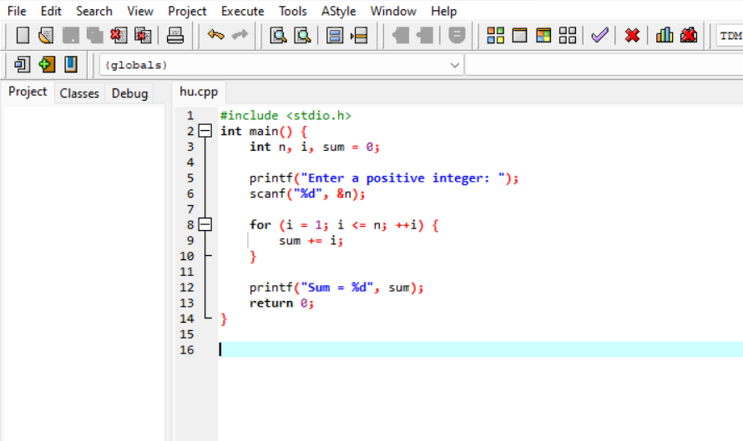

**Output**

